
 | Guide for Configuring SD100 iNICs Using Ansible |  | 
 | Issue | 01
 | Date | 2017-08-17
 | HUAWEI TECHNOLOGIES CO., LTD.

Copyright © Huawei Technologies Co., Ltd. 2017. All rights reserved.
No part of this document may be reproduced or transmitted in any form or by any means without prior written consent of Huawei Technologies Co., Ltd.

Trademarks and Permissions
 and other Huawei trademarks are trademarks of Huawei Technologies Co., Ltd.
All other trademarks and trade names mentioned in this document are the property of their respective holders.

Notice
The purchased products, services and features are stipulated by the contract made between Huawei and the customer. All or part of the products, services and features described in this document may not be within the purchase scope or the usage scope. Unless otherwise specified in the contract, all statements, information, and recommendations in this document are provided "AS IS" without warranties, guarantees or representations of any kind, either express or implied.
The information in this document is subject to change without notice. Every effort has been made in the preparation of this document to ensure accuracy of the contents, but all statements, information, and recommendations in this document do not constitute a warranty of any kind, express or implied.

Huawei Technologies Co., Ltd.
Address: | Huawei Industrial Base  Bantian, Longgang  Shenzhen 518129  People's Republic of China
Website: | http://e.huawei.com
Email: | support@huawei.com

Contents
1 Background and Overview 1
2 Networking Restrictions and Environment Preparations 2
2.1 Networking Restrictions 2
2.2 Environment Preparations 2
3 Configuring SD100 iNICs 3
3.1 Configuring SD100 iNICs for the BMS Service 3
3.1.1 Scenarios 3
3.1.2 Prerequisites 3
3.1.3 Operation Guide 3
3.1.3.1 Configuring SD100 iNICs 3

Background and Overview
This document provides guidance for administrators on how to configure SD100 iNICs in batches using Ansible to improve the efficiency of capacity expansion of BMS PODs.

Networking Restrictions and Environment Preparations

Networking Restrictions
- The management IP address of the SD100 iNIC is the IP address of the External OM plane of the BMS POD.
- The Ansible server can communicate with the External OM plane of the BMS POD at layer 2 or 3.

Environment Preparations
- An Ansible server that can communicate with the target BMS POD
- Controller node of the BMS POD
- Capacity expansion planning table
- FusionSphere OpenStack V100R006C10xxxxxx_Tool.tar
- IP address of the global DNS server
- Domain name or IP address of the global NTP server
- The BMSs for which the SD100 iNICs are to be configured are powered on.

Configuring SD100 iNICs

Configuring SD100 iNICs for the BMS Service

Scenarios
Configure the management IP addresses of the SD100 iNICs if the FusionSphere OpenStack BMS service uses SD100 iNICs to interconnect with FusionStorage Block.

Prerequisites
- You have installed and configured FusionSphere OpenStack.
- You have copied software package FusionSphere OpenStack V100R00xxxxx_Tool.tar to a node that can communicate with the BMC Base network plane of the BMSs to be configured.
- The BMS Intelligent Platform Management Interface (IPMI) version must be 2.32 or later, and the IPMI uses port 623 by default.
- You have installed and configured FusionStorage Block and FusionStorage Manager.
- You have obtained the DNS server IP address and the NTP server domain name from the administrator.
- The BMSs for which SD100 iNICs are to be configured are powered on.

Operation Guide

Configuring SD100 iNICs
- Decompress batch_config_SD100.zip locally, copy Ansible_for_config_SD100.tar.gz to the /home/admin directory of the Ansible server, and run the following command to decompress Ansible_for_config_SD100.tar.gz:
tar -zxvf /home/admin/Ansible_for_config_SD100.tar.gz
- Use the FTP tool to copy the forSD100ConfigDefaultGW.sh script in the batch_config_SD100 directory to the /home/fsp directory of the controller node of the POD where the BMS resides.
Configure the Management IP Addresses of the SD100 iNICs
- Decompress file sdiTool.tar.gz in software package FusionSphere OpenStack V100R00xxxxx_Tool.tar.gz. Copy set_sd100_ip_mask.sh in the sdiTool directory to the /home/fsp directory of the controller node of the POD where the BMS resides.
- Obtain the BMC IP address, username, and password of the BMS where the SD100 iNIC to be configured is located, the management IP address assigned to the SD100 iNIC, and the VLAN ID of this management IP address from the network planning LLD document.
- Log in to the controller node, switch to the directory where set_sd100_ip_mask.sh is stored, and run the following command create the sdi_info.conf file:
vi sdi_info.conf
- Add parameters in the bmcip, bmc_user, bmc_pwd, sd100ip, sd100mask, sd100vlan sequence to the first row in the created file.
If multiple BMS nodes and SD100 iNICs need to be configured, add the parameters of each BMS node in an independent row and then save the sdi_info.conf file.
For example:
BMC IP address 1 BMC username 1 BMS password 1 SD100 iNIC management IP address 1 Subnet mask 1 VLAN 1
BMC IP address 2 BMC username 2 BMC password 2 SD100 iNIC management IP address 2 Subnet mask 2 VLAN 2
BMC IP address 3 BMC username 3 BMC password 3 SD100 iNIC management IP address 3 Subnet mask 3 VLAN 3
Esc
:wq!
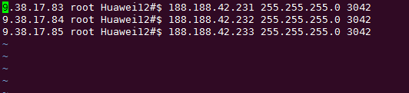

The subnet mask must be in xxx.xxx.xxx.xxx format.
- Run the following command to configure the execution permission for the set_sd100_ip_mask.sh script:
chmod +x set_sd100_ip_mask.sh
- Run the following command to verify that the SD100 iNIC management IP address, subnet mask, and VLAN ID are valid, that the BMC IP address can be pinged, and that the BMC username and password are correct:
./set_sd100_ip_mask.sh -c ./sdi_info.conf

If the verification fails, contact the administrator.
- Run the following command to configure the management IP address of the SD100 iNIC:
./set_sd100_ip_mask.sh -s ./sdi_info.conf

If SD100 iNIC configuration fails, the configuration script returns error codes. The meanings of the error codes are as follows:
- SD100 iNIC internal error.
- BMC network unreachable.
- Incorrect BMC username or password.
- The SD100 iNIC is not powered on.
- The management IP address configuration file of the SD100 iNIC is invalid.
- IP address configuration for the SD100 iNIC timed out.
- SD100 iNIC network restart failed.
- Failed to obtain the bond configuration by restarting the SD100 iNIC.
- Failed to obtain the IP address after the SD100 iNIC restarts.
- The IPMI version is incorrect. Upgrade IPMI to 2.32 or later.
- Invalid configuration file format.
- Log in to the BMS POD controller node where forSD100ConfigDefaultGW.sh is stored, switch to the /home/fsp directory, and run the following command to edit the script (enter the management IP addresses of the SD100 iNICs, gateway, and the VLAN with the management IP address to configure default gateway for the SD100 iNICs):
vim /home/fsp/forSD100ConfigDefaultGW.sh
The following figure shows an example.
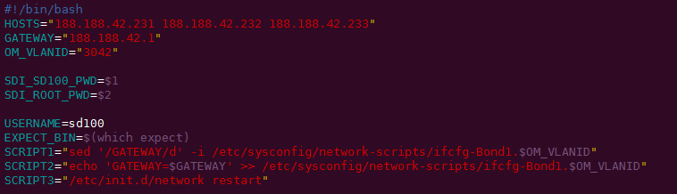
HOSTS: Enter the management IP addresses of SD100 iNICs. Multiple management IP addresses must be separated with spaces.
GATEWAY: Enter the gateway for the management IP addresses of the SD100 iNICs.
OM_VLANID: Enter the network plane VLAN ID of the management IP addresses of SD100 iNICs. The value is the VLAN ID of the External OM plane of the BMS POD.
Other parameters require no change.
Parameters will not be verified. Ensure that all parameters are correctly configured.
- Run the following command to switch to user root, run the forSD100ConfigDefaultGW.sh script in the /home/fsp directory to configure the default gateway for the SD100 iNICs.
su - root
dos2unix /home/fsp/forSD100ConfigDefaultGW.sh
source set_env
1
FusionSphere123
runsafe
sh /home/fsp/forSD100ConfigDefaultGW.sh Huawei12#$ Euler12#$
Huawei12#$ is the default password of user SD100 and Euler12#$ is the default password of user root.

Checking Network Connectivity of SD100 iNICs
- Log in to the Ansible server, switch to the /home/admin/Ansible_for_config_SD100 directory, and run the following command to edit sdi.inventory and add the IP addresses of SD100 iNICs to the SDI host group (set ansible_ssh_user to sd100):
vim /home/admin/Ansible_for_config_SD100/sdi.inventory
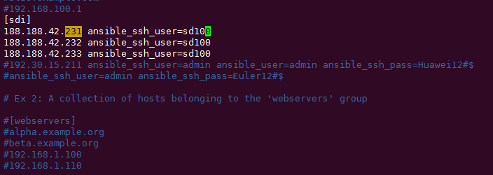

Run the following commands:
Esc
:wq!
- Log in to the Ansible node and run the following command to check whether the management IP addresses of SD100 iNICs can be pinged:
ansible-playbook -i /home/admin/Ansible_for_config_SD100/sdi.inventory /home/admin/Ansible_for_config_SD100/test_connection.yml --ask-pass --su --su-user=root --ask-su-pass
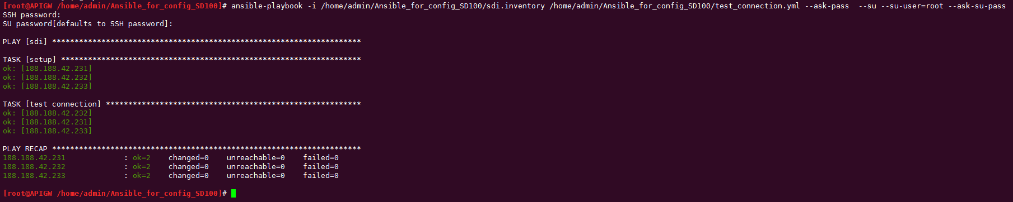

Preparing for Configuring SD100 iNICs
- On an SD100 node, run the following commands to log in to the SD100 iNIC, switch to user root, and enter the password as prompted. Copy the /etc/ntp.conf file of the SD100 iNIC to the /home/admin/ directory of the Ansible server. If the /etc directory contains the resolv.conf file, copy it to the /home/admin directory of the Ansible server, and copy the ssh/sshd_config file in the /etc/ directory to the /home/admin/ directory of the Ansible server.
ssh sd100@SD100 management IP address
Huawei12#$
su - root
Euler12#$
scp /etc/ntp.conf admin@192.30.15.211:/home/admin/Ansible_for_config_SD100/ntp.conf.j2
scp /etc/resolv.conf admin@192.30.15.211:/home/admin/Ansible_for_config_SD100/resolv.conf.j2
scp /etc/ssh/sshd_config admin@192.30.15.211:/home/admin/Ansible_for_config_SD100/sshd_config.j2
admin is the username of the Ansible server and 192.30.15.211 is the IP address of the Ansible server.
- Log in to the controller node of the BMS POD and run the following commands to copy the key files to the Ansible node:
fsp@OMIP
scp /home/fsp/.ssh/id_rsa.pub admin@192.30.15.211:/home/admin/Ansible_for_config_SD100/authorized_keys.j2
OMIP is the controller node of the BMS POD. admin is the username of the Ansible server. 192.30.15.211 is the IP address of the Ansible server.
Configuring the DNS and NTP
- Obtain the DNS IP address from the administrator. Log in to the Ansible server and run the following command to configure the obtained information in the /home/admin/Ansible_for_config_SD100/resolv.conf.j2 file:
vim /home/admin/Ansible_for_config_SD100/resolv.conf.j2
Example
If the DNS IP address is xxx.xxx.xxx.34 and xxx.xxx.xxx.35, add the following content to the configuration file:
nameserver xxx.xxx.xxx.34
nameserver xxx.xxx.xxx.35
- Run the following commands to save the change and exit:
Esc
:wq!
- Obtain the NTP domain name or IP address from the administrator. Log in to the Ansible server and run the following command to configure the obtained information in the /home/admin/Ansible_for_config_SD100/ntp.conf.j2 file:
vim /home/admin/Ansible_for_config_SD100/ntp.conf.j2
Change the NTP IP address in the /home/admin/Ansible_for_config_SD100/ntp.conf.j2 file to the NTP domain name obtained from the administrator
For example, if the NTP domain name is xxx.xxx.xxx, run the following commands:
server xxx.xxx.xxx
fudge xxx.xxx.xxx stratum 10
- Log in to the Ansible server and run the following command to configure DNS and NTP:
ansible-playbook -i sdi.inventory sdi.yml --ask-pass --su --su-user=root --ask-su-pass
Setting the SD100 iNIC Login Mode to the Key
- Log in to the Ansible server and run the following command to edit the /home/admin/Ansible_for_config_SD100/sshd_config.j2 file:
vim /home/admin/Ansible_for_config_SD100/sshd_config.j2
Configure the RSAAuthentication, PubkeyAuthentication, and PermitRootLogin files. If the sshd_config.j2 file does not have these parameters, add them.
RSAAuthentication yes
PubkeyAuthentication yes
PermitRootLogin no
- Log in to the Ansible server and run the following command to set the SD100 iNIC login mode to key:
ansible-playbook -i sdi.inventory sdi_ssh_config.yml --ask-pass --su --su-user=root --ask-su-pass
- Log in to the SD100 iNIC node using a key. If you can log in successfully, the configuration is successful.
- (Optional) log in to the Ansible server and run the following command to edit the /home/admin/Ansible_for_config_SD100/sshd_config file:
vim /home/admin/Ansible_for_config_SD100/sshd_config.j2
ansible-playbook -i sdi.inventory sdi_ssh_config.yml --ask-pass --su --su-user=root --ask-su-pass
Set the value of PasswordAuthentication to no to disable login to the SD100 iNIC through the password.
After performing this operation, you can only log in to the SD100 iNIC using the key. If you need to configure the iNIC using Ansible, you can only use a key for authentication. Therefore, perform this operation based on your requirements.
The operations to use a key for login authentication are as follows:
Upload the key to the /home/admin directory, add the key to [sdi] in the /home/admin/Ansible_for_config_SD100/sdi.inventory file.
After the login is successful, run the ansible command to configure the SD100 iNICs.
